Functional Specification Document
  - OMEGA – Open Market Execution Gateway
  - Bid Collation
  - v0.01

Document Control
Revision History
Revision # | Release Date | Summary of Changes | Author
0.01 | 12 Dec 2025 | Initial draft. | Eugene Cheong

Reviewer Name (Designation) | Reviewed Version # | Date

Approver Name (Designation) | Approved Version # | Date

Table of Contents
1 Introduction 6
1.1 Purpose of Document 6
1.2 Scope 6
1.3 Definitions, Acronyms and Abbreviations 6
1.4 Reference 6
2 Functional Requirements 7
2.1 Purpose of Module 7
2.2 Actors 7
2.3 Process Diagrams 7
2.4 BPMN Workflow 8
2.5 State Transition Diagram 8
2.6 Use Cases 8
2.7 View Bids 9
2.7.1 Description 9
2.7.2 Preconditions 9
2.7.3 Business Requirements 9
2.7.4 Post Conditions 10
2.7.5 Bid Management Listing Page 10
2.7.6 Bid Details Page 12
2.8 Create Bid 15
2.8.1 Description 15
2.8.2 Preconditions 15
2.8.3 Business Requirements 15
2.8.4 Post Conditions 15
2.8.5 Bid Details Page 16
2.8.6 Upload File Modal 16
2.8.7 Upload File Confirmation Prompt 17
2.8.8 Create Bid Modal 18
2.8.9 Create Bid Confirmation Prompt 20
2.9 Update Bid 21
2.9.1 Description 21
2.9.2 Preconditions 21
2.9.3 Business Requirements 22
2.9.4 Post Conditions 22
2.9.5 Bid Details Page 22
2.9.6 Update Bid Modal 22
2.9.7 Update Bid Confirmation Prompt 25
2.10 Delete Bid 25
2.10.1 Description 25
2.10.2 Preconditions 25
2.10.3 Business Requirements 26
2.10.4 Post Conditions 26
2.10.5 Bid Details Page 26
2.10.6 Delete Bid Modal 26
2.10.7 Delete Bid Confirmation Prompt 27
2.11 Withdraw Bid Approval Request 28
2.11.1 Description 28
2.11.2 Preconditions 28
2.11.3 Business Requirements 28
2.11.4 Post Conditions 28
2.11.5 Bid Details page 28
2.11.6 Withdraw Bid Modal 29
2.12 Approve/Reject Bids 29
2.12.1 Description 29
2.12.2 Preconditions 29
2.12.3 Business Requirements 30
2.12.4 Post Conditions 30
2.12.5 Bid Details page 30
2.12.6 Review Bid Modal 31
2.12.7 Review Bid Confirmation Prompt 32
2.13 Download Bid File Template 33
2.13.1 Description 33
2.13.2 Preconditions 33
2.13.3 Business Requirements 33
2.13.4 Post Conditions 33
2.13.5 Bid Details page 33
2.13.6 Template Files 34
2.14 Export Bids 34
2.14.1 Description 34
2.14.2 Preconditions 34
2.14.3 Business Requirements 34
2.14.4 Post Conditions 34
2.14.5 Bid Details page 34
2.14.6 Sample Files 35

Introduction

Purpose of Document
This Functional Specification Document is used to clearly define the intended functionality of OMEGA.
OMEGA is a platform that supports MAS’ central banking functions related to market operations and benchmark administration. OMEGA aims to improve business efficiency by leveraging on technology and design thinking, minimising manual intervention, re-engineering business processes and improving system resiliency.
OMEGA consists of several modules. This document outlines the functionality of the Bonds and Bills module, focusing on features, functions, and behaviour specifically for bid collation for internal users, without detailing how these functionalities will be technically implemented. It aims to:
- Establish a shared understanding of the system's functional scope;
- Provide a clear and unambiguous description of each functional requirement;
- Ensure that the developed system meets the identified business needs and user expectations;
- Facilitate effective communication and collaboration among all project stakeholders;
- Serve as a baseline for system development, testing, and implementation; and
- Manage and control changes to the system's functionality through a defined change management process.

Scope
The Bonds and Bills module allows MAS internal users to perform the following functionalities:
- View bids;
- Create bids on behalf of FIs and MAS;
- Update bids on behalf of FIs and MAS;
- Delete bids on behalf of FIs and MAS;

- Submit new/updated/deleted bids for approval, or withdraw them from approval;

- Approve or reject new/updated/deleted bids as part of the maker-checker process;
- Download bid file templates to share with FIs which can be later uploaded by MAS on behalf of FIs or by FIs, to create new bids; and
- Export bids

Definitions, Acronyms and Abbreviations
Acronym | Description
BPMN | Business Process Model and Notation
CDP | Central Depository Pte Limited
FI | Financial Institution
MAS | Monetary Authority of Singapore
OMEGA | Open Market Execution Gateway
PD | Primary Dealer
SGS | Singapore Government Securities
SSB | Singapore Savings Bonds
Table 1: Acronyms used in document

Reference
The following documents are referenced throughout this functional specification and should be consulted for additional context, detailed requirements, and technical information that supports the functional requirements described in this document.
- MAS_OMEGA – Functional Specifications Document (Announcement).docx
- MAS_OMEGA – Functional Specifications Document (Administration).docx
- MAS_OMEGA – Functional Specifications Document (External Users).docx
- MAS_OMEGA – Functional Specifications Document (Allotment).docx
- MAS_OMEGA – Functional Specifications Document (Common Functions).docx
- MAS_OMEGA – Additional Information (Error Messages).xlsx – This file contains a list of validations in each module and their corresponding error messages.
- MAS_OMEGA – Additional Information (System Notifications and Emails).xlsx – This file contains a list of system notifications and emails in each module and their corresponding content.

Functional Requirements

Purpose of Module
MAS internal users can manage bids on behalf of FIs and MAS.
OMEGA contains inbound interfaces from Retail PDs to receive the retail bid batch files. In addition, notifications in the form of emails and/or system notifications are available.

Actors
The actors identified for this module are as follows:
Actors | Description
Bid Collation Maker | The entity responsible for viewing and managing bids by creating, updating, and deleting them on behalf of FIs and MAS.
Bid Collation Checker | The entity responsible for approving the creation, update, and deletion of bids.
Bid Collation Viewer | The entity who is allowed to only view and filter bids but not allowed to manage or approve them.
Table 2: Actors of module

Process Diagrams
The figure below shows the high-level activities when a bidding window is open:
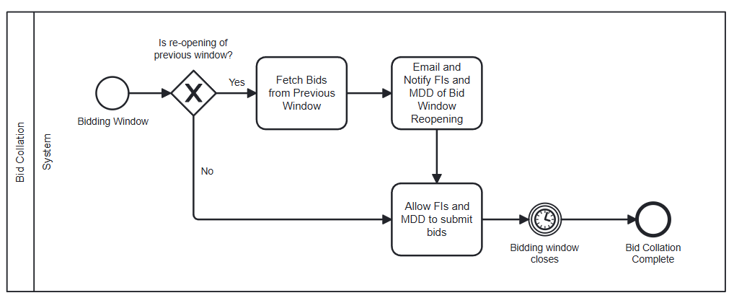
Figure 1: Overview of bid collation
When the announcement for an auction or a mini-auction is published to the MAS website, i.e. completion of announcement workflow, the bidding window for the issuance is opened. For more information on the announcement publication process, refer to MAS_OMEGA – Functional Specifications Document (Announcement).
When the bidding window for an issuance is open, new bids can be submitted. Existing bids can also be amended or deleted by both internal and external users. This document contains information related to bid collation for internal users only. For external users, refer to MAS_OMEGA – Functional Specifications Document (External Users).
The bidding window is scheduled to close at the closing time on the auction date. The closing time is a configurable parameter that is set for the issuance upon the first approval of the corresponding announcement. For more information on managing this parameter, refer to MAS_OMEGA – Functional Specifications Document (Administration).

After the bidding window closes, the next step is for OMEGA to run the allotment process at the specified time. Only internal users can manage bids after the bidding window has closed. Internal users can also update the bidding window (even after the window has closed) to a later time within the same day, for external users to submit new bids or amend existing bids. These processes and use cases are documented in MAS_OMEGA – Functional Specifications Document (Allotment).

BPMN Workflow
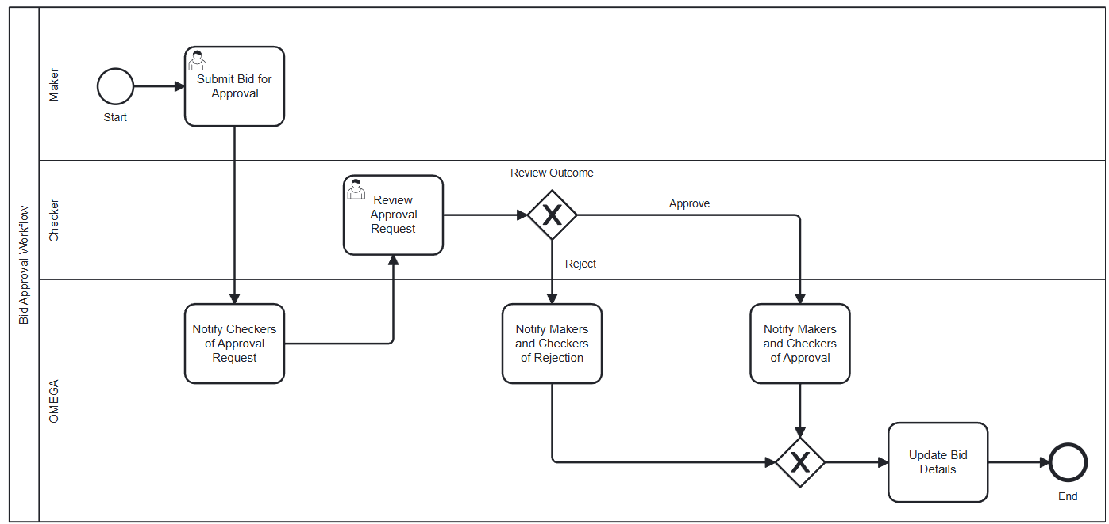
Figure 2: BPMN workflow for bids
In this module,
- An instance of the BPMN workflow above is created when a Maker creates, updates, or deletes bids and submits it for approval.
- When new/amended/deleted bids are submitted for approval, OMEGA notifies the Checkers of the approval request that is pending their review.
- The Checker reviews the bid approval request with the option to approve or reject the request.
- When approved, the Makers and the Checkers are notified of the approved request, and OMEGA will insert, update, or delete the bid details based on the type of request.
- When the request is rejected, the Makers and the Checkers are notified of the rejected request, and no changes to the existing bids are made.

State Transition Diagram
The figure below shows the possible status transitions that a bidding window may undergo, and the conditions required to trigger these transitions.
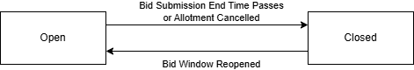
Figure 3: State transition diagram for bidding windows
There are only two statuses: Open or Closed. It is not required to differentiate whether a bidding window is open because of an extension or a reopening.
In addition to the status of a bidding window, bids have their own statuses. The figure below shows the possible status transitions that a bid may undergo, and the conditions required to trigger these transitions.
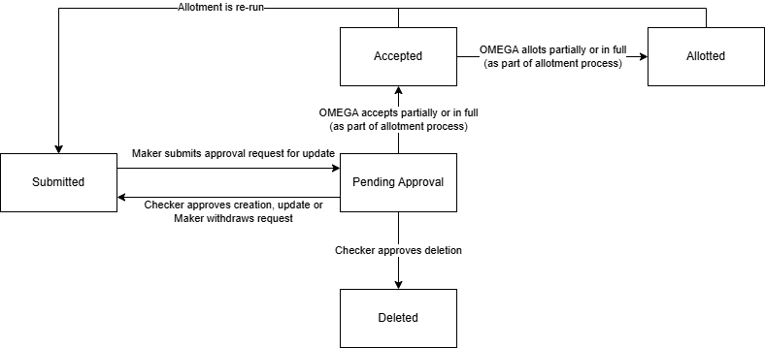
Figure 4: State transition diagram for bids

Use Cases

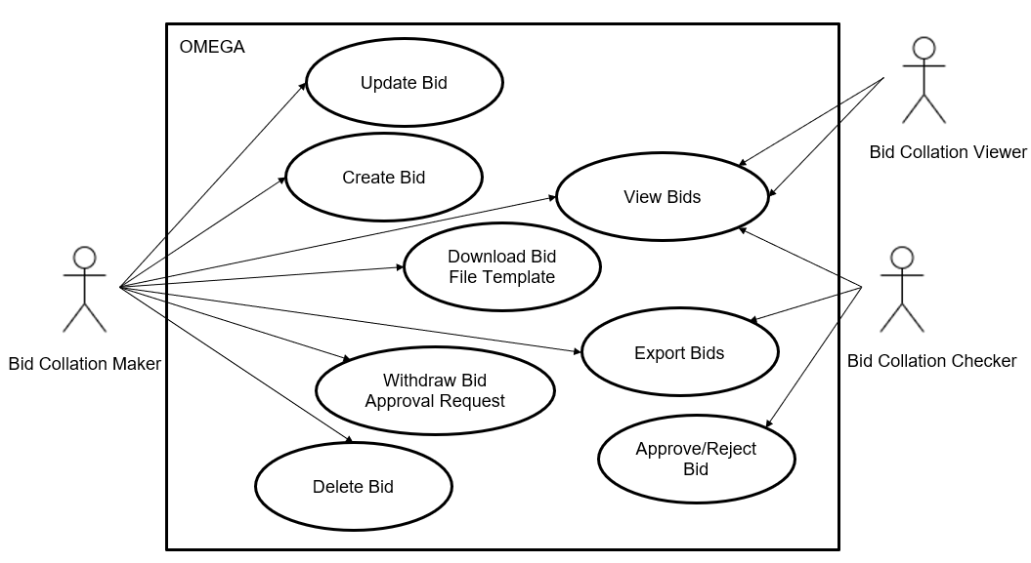
Figure 5: Use case diagram
The use cases covered within this module are:
- View Bids
- Create Bid
- Update Bid
- Delete Bid
- Withdraw Bid Approval Request
- Approve/Reject Bid Approval Request
- Download Bid File Template
- Export Bids

View Bids

Description
This use case enables users to view and filter bids.

Preconditions
- User logs in to the Intranet Portal.
- User accesses the Bid Management Listing Page.

Business Requirements
- Role-based Access Control:
  - Bid Collation Maker – is not able to see the Pending Approvals Accordion in the Bid Details Page.
  - Bid Collation Checker – is not able to see the actions Create bid, Update bid, Delete bid, File upload and Download template(s) in the Bid details page.
  - Bid Collation Viewer – is not able to see the actions Create bid, Update bid, Delete bid, File upload and Download template in the Bid details page. Will not be able to see the Pending Approvals Accordion in the Bid Details page.

Post Conditions
- User views the bids for a particular issuance that was submitted via manual entry or file upload.

Bid Management Listing Page
The Bid Management Page contains the following screen elements:
- Page Header
- Data Table Action Bar
- Filter Drawer
- Data Table
Default Sorting: (1) descending order of pending approvals, then (2) descending order of bid submission end.
Default Filter: Only show records whose auction status is open.
All bids (i.e. created via manual entry, file uploade, or interface files) can be viewed.

Wireframe
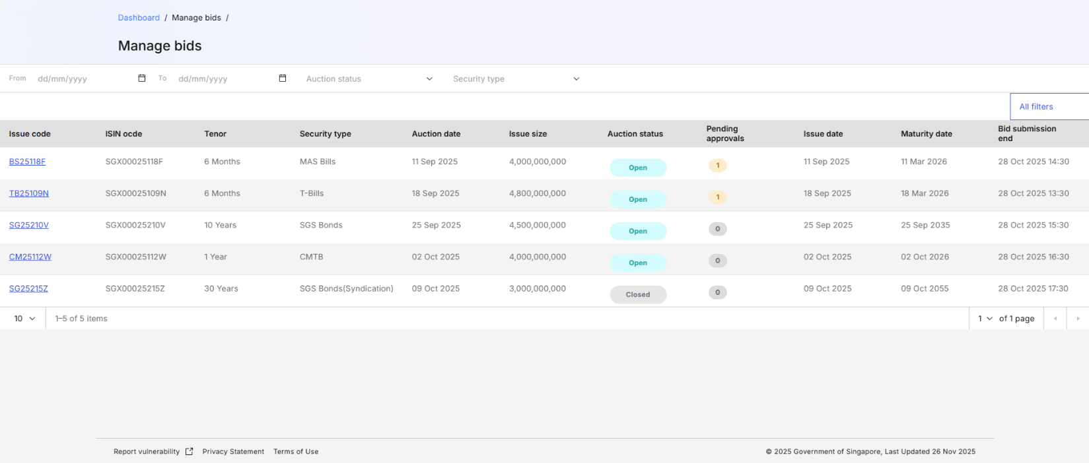
Figure 6: Bid Management Listing Page
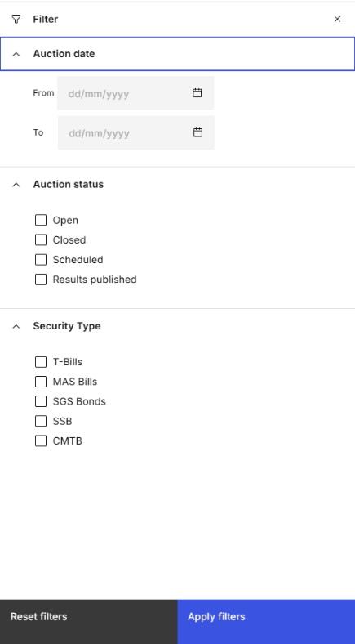
Figure 6: Bid Management Listing Page – Filter Drawer

Page Header
S/N | Name | Type  (Max Length) | Validation Rules | Remarks
1 | Home / Manage bids / | Breadcrumb
2 | Manage bids | Page Title
Table 3: Page Header Screen Elements

Data Table Action Bar
S/N | Name | Type  (Max Length) | Validation Rules | Remarks
1 | Auction Date From | Date Picker |  | Filters using the Auction date. The date selected is inclusive.
2 | To | Date Picker |  | Filters using the Auction date. The date selected is inclusive. Maximum value is the current date.
3 | Auction status | Multiselect Dropdown |  | Refer to MAS_OMEGA – Functional Specifications Document (Allotment).docx for a list of available options.
4 | Security type | Multiselect Dropdown |  | Options available are:  - SGS Bonds  - MAS Bills  - T-Bills  - SSBs  - CMTBs  Additional options are available based on the name when new security types are created.
Table 4: Data Table Action Bar Screen Elements

Filter Drawer
S/N | Name | Type  (Max Length) | Validation Rules | Remarks
1 | Auction date | Date Range Picker |  | Filters using the Auction date. The date selected is inclusive. Maximum value of the To date field is the current date.
2 | Auction status | Checkbox |  | Refer to MAS_OMEGA – Functional Specifications Document (Allotment).docx for a list of available options.
3 | Security type | Checkbox |  | Options available are:  - SGS Bonds  - MAS Bills  - T-Bills  - SSBs  - CMTBs  Additional options are available based on the name when new security types are created.
Table 5: Filter Drawer Screen Elements
Refer to MAS_OMEGA – Functional Specifications Document (Common Functions).docx for the common screen elements and functionalities used in the Filter Drawer.

Data Table
S/N | Name | Type  (Max Length) | Validation Rules | Remarks
1 | Issue code | Label (with hyperlink) |  | Displays the issue code for the issuance.  Clicking on the hyperlink navigates the user to the Bid Details Page based on the issue code and issue date of the row.
2 | ISIN code | Label |  | Displays the ISIN code for the security being issued.
3 | Tenor | Label |  | Displays the Tenor of the issuance.  Options available depends on the tenors available for the security type.
4 | Security type | Label |  | Displays the security type for the issuance.
5 | Auction date | Label |  | Displays the auction date for the issuance.
6 | Issue size | Label |  | Displays the issue size for the issuance.
7 | Auction status | Label |  | Displays the status of the auction for the issuance. Options available are:  - Open  - Closed  - In progress  - Results published
8 | Pending approvals | Label |  | Displays the number of actions pending for the checker to review.
9 | Issue date | Label |  | Displays the issue date for the issuance.
10 | Maturity date | Label |  | Displays the maturity date for the issuance.
11 | Bid submission end | Label |  | Displays the ending date and time which external users can manage bids for the issuance until.
Table 6: Data Table Screen Elements

Bid Details Page
The Bid Details Page contains the following screen elements:
- Page Header
- Pending Approvals Accordion (for institutional bids)
- Data Table Action Header (for institutional bids)
- Data Table (for institutional bids)
- Pending Approvals Accordion (for retail bids)
- Data Table Action Header (for retail bids)
- Data Table (for retail bids)
- Action Button Row

Wireframe
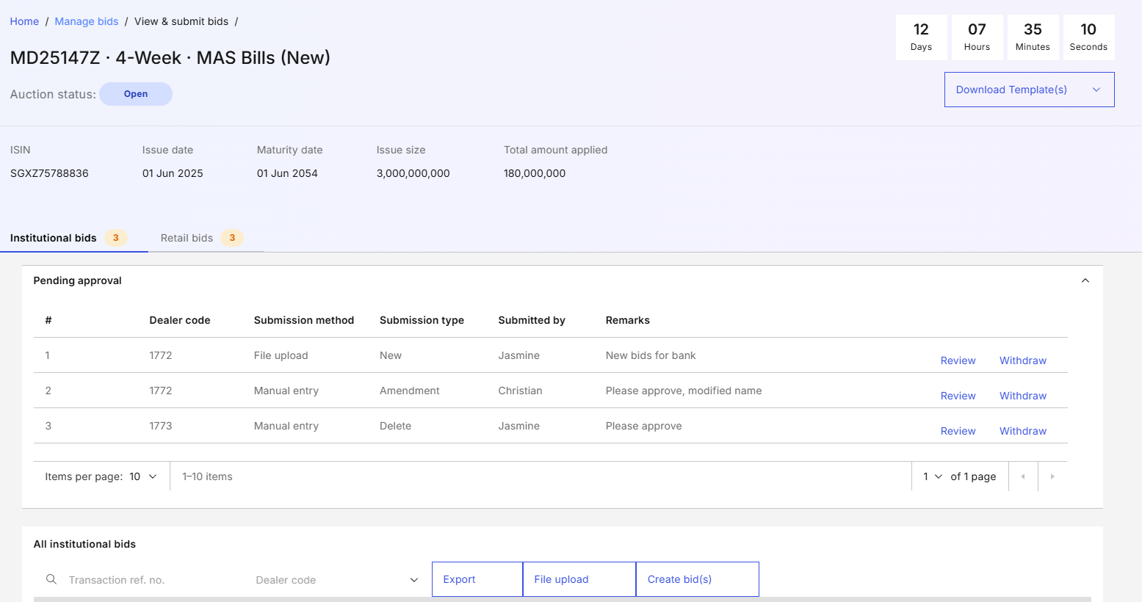
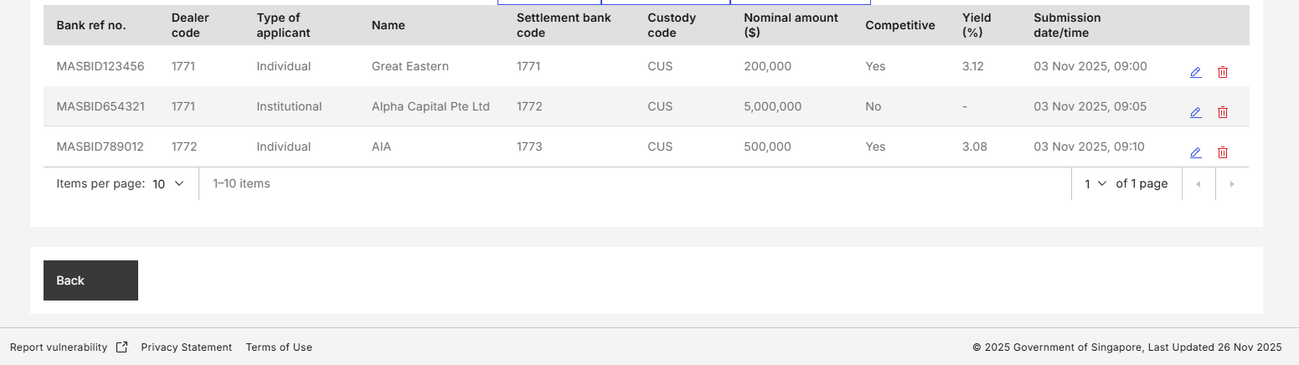
Figure 6: Bid Details Page – with Institutional Bids
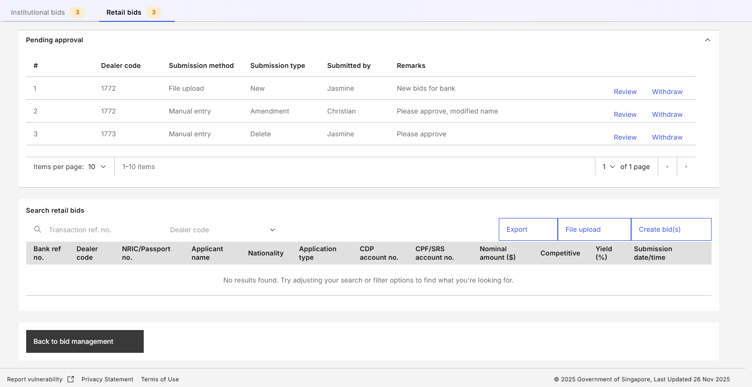
Figure 7: Bid Details Page – Retail bids

Page Header
S/N | Name | Type  (Max Length) | Validation Rules | Remarks
1 | Home / Manage bids / View & submit bids | Breadcrumb
2 | Issue code . Tenor . Security type New/reopen . SubType (if applicable) | Page title |  | e.g. "MD25147Z · 4-week · MAS Bills (New)".
3 | Auction status | Status indicator |  | Displays the status for the auction.
4 | Remaining time for bids submission. | Countdown timer |  | Displays the remaining time from current datetime to the bid submission end time.
5 | Download template(s) | Tertiary button with dropdown |  | Refer to 2.13 Download Bid File Template.
6 | ISIN code | Label
7 | Auction date | Label
8 | Issue date | Label
9 | Maturity date | Label
10 | Issue size | Label
11 | Total amount applied | Label
Table 7: Page Header Screen Elements

Pending Approvals Accordion (for institutional bids)
S/N | Name | Type  (Max Length) | Validation Rules | Remarks
1 | Dealer code | Label |  | Display the dealer code of the PD that the bid is submitted under.
2 | Submission method | Label |  | Display whether the approval requested was submitted via file upload or manual entry.  Options available are:  - Manual entry  - File upload
3 | Submission type | Label |  | Display whether the request is for a new bid, for an update to an existing bid, or to delete a bid.  Options available are:  - New  - Amendment  - Delete
4 | Submitted by | Label |  | Display the name of the user who submitted the approval request.
5 | Remarks | Label |  | Display the remarks made by the user when submitting the approval request.
6 | Review | Hyperlink |  | Refer to 2.12 Approve/Reject Bids. Only for Checkers.
7 | Withdraw | Hyperlink |  | Refer to 2.11 Withdraw Bid Approval Request. Only for Makers.
Table 8: Pending Approvals Accordion Screen Elements

Data Table Action Header (for institutional bids)
S/N | Name | Type  (Max Length) | Validation Rules | Remarks
1 | Bank ref no. | Text (8)
2 | Dealer code | Multiselect Dropdown |  | Options available are based on the dealer code of each PD.
Table 9: Data Table Action Header Screen Elements

Data Table (for institutional bids)
S/N | Name | Type  (Max Length) | Validation Rules | Remarks
1 | Bank ref no. | Label
2 | Dealer code | Label
3 | Type of applicant | Label
4 | Name | Label
5 | Settlement bank code | Label
6 | Custody code | Label
7 | Nominal amount ($) | Label
8 | Competitive | Label |  | Options available are:  - Yes  - No
9 | Yield (%) | Label |  | Display this value if Competitive is “Yes”. Otherwise, display “-“.
10 | Submission date/time | Label
Table 10: Data Table Screen Elements

Pending Approvals Accordion (for retail bids)
Refer to 2.7.6.3 Pending Approvals Accordion (for institutional bids).

Data Table Action Header (for retail bids)
Refer to 2.7.6.4 Data Table Action Header (for institutional bids).

Data Table (for retail bids)
S/N | Name | Type  (Max Length) | Validation Rules | Remarks
1 | Bank ref no. | Label
2 | Dealer code | Label
3 | NRIC/Passport no. | Label
4 | Name | Label
5 | Nationality | Label
6 | Application type | Label
7 | CDP account no. | Label
8 | CPF/SRS account no. | Label
9 | Nominal amount ($) | Label
10 | Competitive | Label
11 | Yield (%) | Label
12 | Submission date/time | Label
Table 11: Data Table Screen Elements

Action Button Row
S/N | Name | Type  (Max Length) | Validation Rules | Remarks
1 | Back | Tertiary button |  | Redirect back to Manage Bids page, retaining the search filter and results.
Table 12: Action Button Row Screen Elements

Create Bid

Description
This use case enables Makers to create bids for an issuance.

Preconditions
- User logs in to the Intranet Portal.
- User accesses the Bid Details Page.
- The result for the auction/allotment is not released or is unpublished.

Business Requirements
- Role-based Access Control:
  - Bid Collation Maker
- Makers are able to create bids via manual entry and via file upload. Partial acceptance of bids from the uploaded file will take place if there are errors for some of the bids in the file.
- Error details from the uploaded file will be reflected, and rows containing the error and the bank reference number shown.
- File upload will be for the purpose of inserting bids and not to update bids.
- For each PD, no two bids can share the same bank reference number for the same issuance.

- Makers can create bids even when the bidding window is closed.

Post Conditions
- An instance of the BPMN workflow is created.
- The newly created bid appears in the Pending Approvals Accordion as awaiting approval.
- The event is added to the audit log and submission history.
- Emails and notifications are sent to the checkers to inform them of the newly created bid which was submitted for approval.
- User stays in the Bid Details Page.
- User views a temporary toast notification informing that the bid creation was successful.

Bid Details Page
In this use case, the Bid Details Page contains a "File upload" and a "Create bid" button in the data table action header.

Wireframe
Refer to 2.7.6.1 Wireframe.

Data Table Action Header
S/N | Name | Type  (Max Length) | Validation Rules | Remarks
1 | File upload | Tertiary button |  | Opens the upload file modal.
2 | Create bid | Tertiary button |  | Opens the create bid modal.
Table 13: Data Table Action Header Screen Elements

Upload File Modal

Wireframe
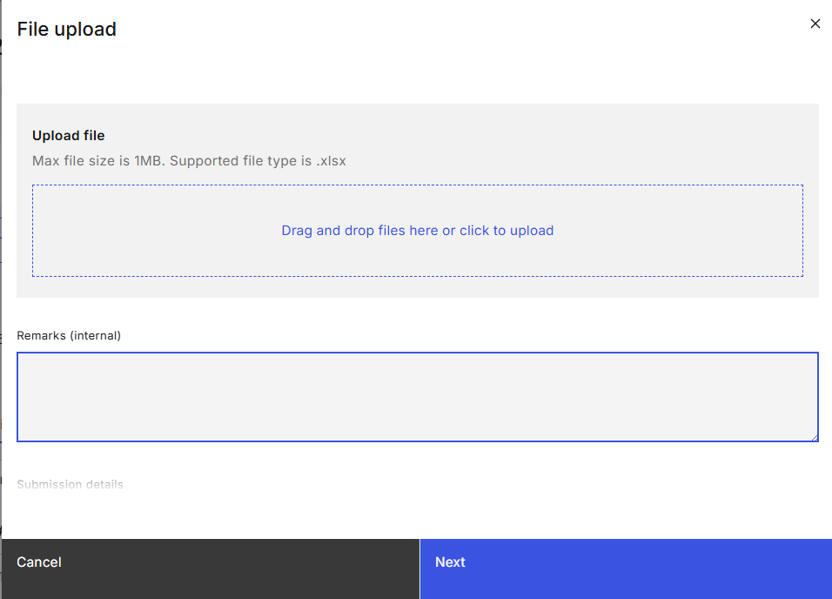
Figure 8: Upload File Modal

Screen Elements
S/N | Name | Type  (Max Length) | Validation Rules | Remarks
1 | Upload file | File Upload Container |  | Max file size is 1MB.  Supported file type is .xlsx.
2 | Remarks (internal) |  |  | Refer to MAS_OMEGA – Functional Specifications Document (Common Functions) for the screen elements used and its functionalities.
3 | Next | Primary Button |  | Displays the upload file confirmation prompt.
Table 14: Upload File Modal Screen Elements

Upload File Confirmation Prompt

Wireframe
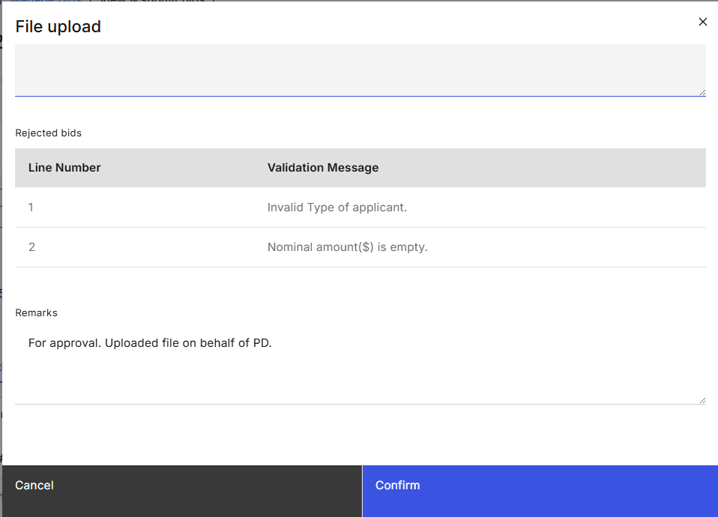
Figure 9: Upload File Confirmation Prompt

Screen Elements
S/N | Name | Type  (Max Length) | Validation Rules | Remarks
1 | Rejected bids | Data table | Duplication check based on bank reference number. | Shows the line number of rejected bids as well as the reason why the bid was invalid.
2 | Remarks (internal) |  |  | Refer to MAS_OMEGA – Functional Specifications Document (Common Functions) for the screen elements used and its functionalities.
3 | Confirm | Primary Button |  | Submits the bid for approval. Refer to 2.8.4 Post Conditions.
Table 15: Upload File Confirmation Prompt Screen Elements

Create Bid Modal

Wireframe
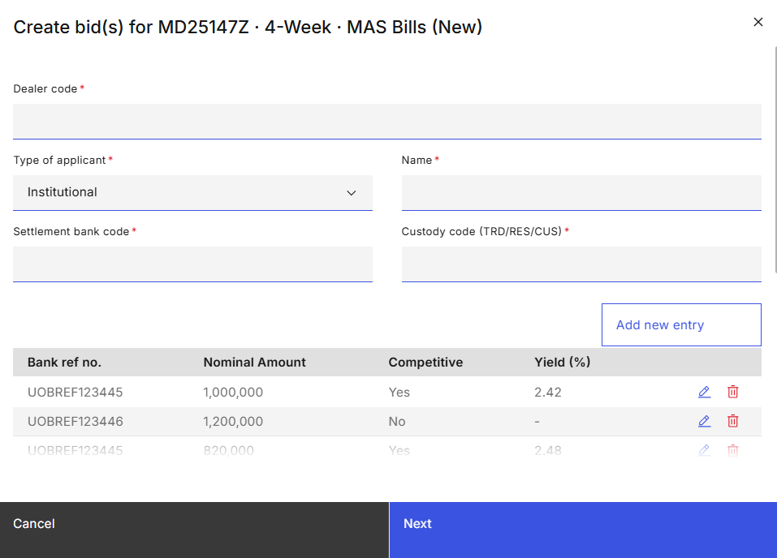
Figure 10: Create Bid Modal

Screen Elements
S/N | Name | Type  (Max Length) | Validation Rules | Remarks
1 | Issue code . Tenor . Security type New/reopen . SubType (if applicable) |  |  | e.g. "Create bid(s) for MD25147Z · 4-week · MAS Bills (New)".
2 | Dealer code | Dropdown | Hard Validations:  - Required field. | Options available are based on the dealer code of each PD.  Visible and mandatory for both institutional and retail bids.
3 | Type of applicant | Dropdown | Hard Validations:  - Required field. | Visible and mandatory for institutional bids.  Options available are:  - Primary Dealer (PD)  - Full Bank (FB)  - Restricted Bank (RB)  - Offshore Bank (OB)  - Other Bank – customer of another bank (NB)  - Merchant Bank (MB)  - Investment Advisor (IA)  - Finance Company (FC)  - Insurance Company (INS)  - Statutory Board, Government Linked Company (SB)  - Individual (IND)  - Singapore Exchange (SGX)  - Monetary Authority of Singapore (MAS)  - Others (OTH)
4 | Name | Text (30) | Hard Validations:  - Required field. | Visible and mandatory for institutional bids depending on Type of applicant selected.
5 | Settlement bank code | Text (4) | Hard Validations:  - Required field.  - Must be numeric. | Visible and mandatory for institutional bids.
6 | Custody code | Dropdown | Hard Validations:  - Required field. | Visible and mandatory for institutional bids.  Options available are:  - TRD  - RES  - CUS
7 | NRIC/Passport no. | Text (9) | Hard Validations:  - Required field. | Visible and mandatory for retail bids.
8 | Name | Text (30) | Hard Validations:  - Required field. | Visible and mandatory for retail bids.
9 | Nationality | Text (20) | Hard Validations:  - Required field. | Visible and mandatory for retail bids.
10 | Application type |  | Hard Validations:  - Required field. | Visible and mandatory for retail bids.  Options available are:  - CASH  - SRS  - CPFIS – OA  - CPFIS – SA  Options available depend on whether the security type allows for institutional and/or retail bids.  If there is only one option, it will be the default value.
11 | CDP account no. | Text (16) |  | Visible and mandatory for retail bids whose application type is “CASH”.
12 | CPF/SRS account no. | Text (12) |  | Visible and mandatory for retail bids whose application type is “CPFIS-OA” or “CPFIS-SA” or “SRS”.
13 | Add new entry | Tertiary button |  | Adds a new row at the top of the data table.
14 | Bank ref. no. | Text (8) | Hard Validations:  - Required field.  - Must not be used in other bids by the same PD for the same issuance.
15 | Nominal amount ($) | Text (15) | Hard Validations:  - Required field.  - Must be divisible by the denomination without any remainder.  - Minimum nominal amount must match the “Minimum denomination” value configured in security type parameter setting except for Type of applicant = MAS.  For Type of applicant = MAS, the nominal amount can be zero. | Large denomination shortcut key applies for this field.
16 | Competitive | Dropdown | Hard Validations:  - Required field. | Options available are:  - Yes  - No  Options available depend on whether the security type allows for competitive or non-competitive bids.  If there is only one option, it will be the default value.
17 | Yield (%) | Text (6v2) | Hard Validations:  - Required field.  - Must be within the range 0.01 to 99.99 when negative yield is not allowed (0 is not a valid yield)  - Must be within the range -99.99 to 99.99 when negative yield is allowed (0 is a valid yield) | Negative yields are only allowed if configured for the security type.
18 | Remarks (internal) |  |  | Refer to MAS_OMEGA – Functional Specifications Document (Common Functions) for the screen elements used and its functionalities.
19 | Next |  |  | Displays the Create Bid Confirmation Prompt.
Table 16: Create Bid Modal Screen Elements

Create Bid Confirmation Prompt

Wireframe
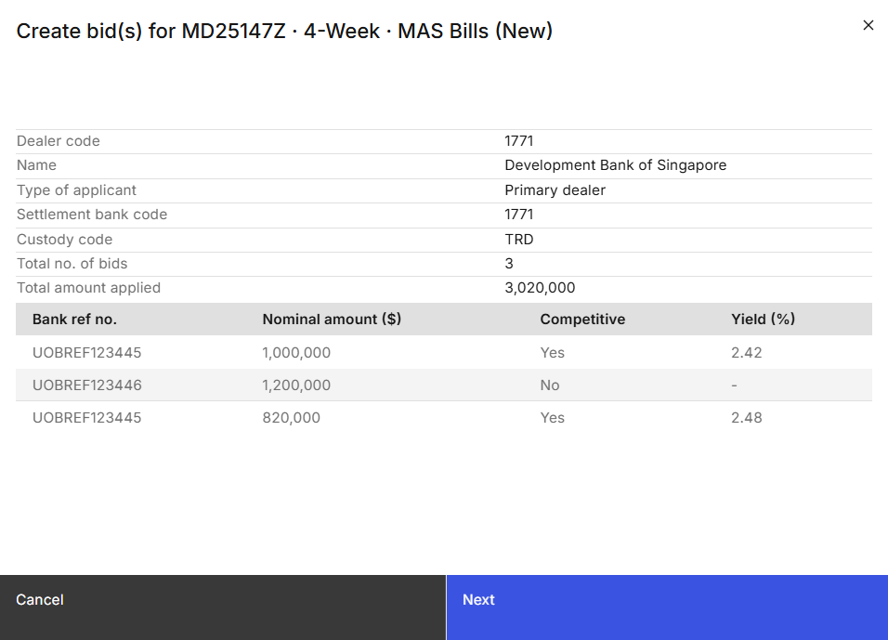
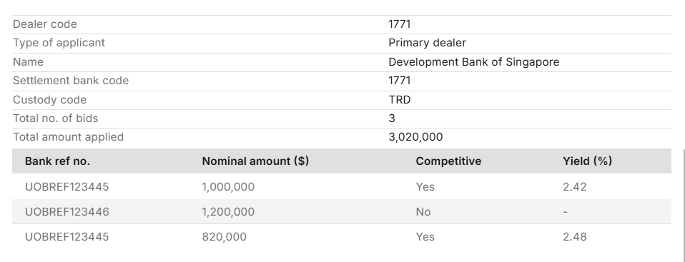
Figure 11: Create Bid Confirmation Prompt

Screen Elements
S/N | Name | Type  (Max Length) | Validation Rules | Remarks
1 | Issue code . Tenor . Security type New/reopen . SubType (if applicable) | Modal title |  | e.g. "Create bid(s) for MD25147Z · 4-week · MAS Bills (New)".
2 | Dealer code | Label
3 | Type of applicant | Label |  | Visible for institutional bids.
4 | Name | Label |  | Visible for institutional bids.
5 | Settlement bank code | Label |  | Visible for institutional bids.
6 | Custody code | Label |  | Visible for institutional bids.
7 | NRIC/Passport no. | Label |  | Visible for retail bids.
8 | Name | Label |  | Visible for retail bids.
9 | Nationality | Label |  | Visible for retail bids.
10 | Application type | Label |  | Visible for retail bids.
11 | CDP account no. | Label |  | Visible for retail bids whose application type is “CASH”.
12 | CPF/SRS account no. | Label |  | Visible for retail bids whose application type is “CPFIS-OA” or “CPFIS-SA” or “SRS”.
13 | Total no. of bids | Label |  | Displays the total number of bids submitted within this modal.
14 | Total amount applied | Label |  | Displays the sum of the nominal amount submitted for all bids within this modal.
15 | Bank ref. no. | Label
16 | Nominal amount ($) | Label
17 | Competitive | Label
18 | Yield (%) | Label
19 | Remarks (internal) | Label |  | Refer to MAS_OMEGA – Functional Specifications Document (Common Functions) for the screen elements used and its functionalities.
20 | Confirm | Primary button |  | Submits the created bid(s) for approval. Refer to 2.8.4 Post Conditions.
Table 17: Create Bid Confirmation Prompt Screen Elements

Update Bid

Description
This use case enables Makers to update institution and retail (?) bids for an issuance.

Preconditions
- User logs in to the Intranet Portal.
- User accesses the Bid Details Page.
- The result for the auction/allotment is not released or is unpublished.
- The bid is not pending approval for updates or requests for deletion.

Business Requirements
- Role-based Access Control:
  - Bid Collation Maker
- Makers are only able to update bids via manual entry and not via file upload or batch file.
- For each PD, no two bids can share the same bank reference number for the same issuance.
- Bids that are pending approval cannot be updated without the original request being approved, rejected, or withdrawn.

Post Conditions
- An instance of the BPMN workflow is created.
- The newly updated bid appears in the Pending Approvals Accordion.
- The event is added to the audit log and submission history.
- Emails and notifications are sent to the checkers to inform them of the newly updated bid which was submitted for approval.
- User stays in the Bid Details Page.
- User views a temporary toast notification informing that the bid update was successful.

Bid Details Page
The Bid Details page contains additional element in the Data Table (for institutional bids) and the Data Table (for retail bids). For the maker to enter remarks as part of the maker-checker process, row-level editing is not available here.

Wireframe
Refer to 2.7.6.1 Wireframe.

Data Tables (for both institutional bids and retail bids)
S/N | Name | Type  (Max Length) | Validation Rules | Remarks
1 | Edit | Icon |  | Opens the Update Bid Modal.
Table 18: Data Table Screen Elements

Update Bid Modal

Wireframe
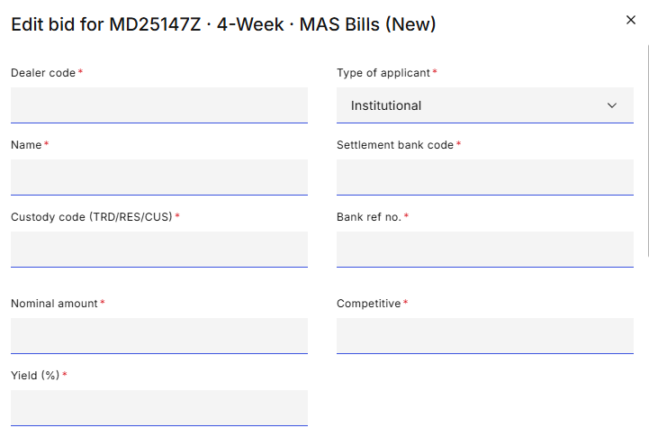
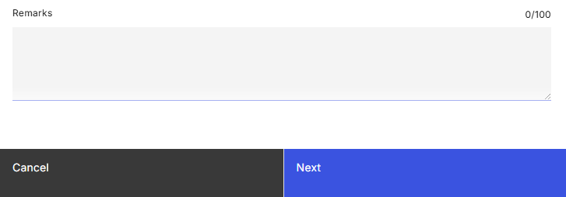
Figure 12: Update Bid Modal

Screen Elements
S/N | Name | Type  (Max Length) | Validation Rules | Remarks
1 | Issue code . Tenor . Security type New/reopen . SubType (if applicable) | Modal title |  | e.g. "Edit bid for MD25147Z · 4-week · MAS Bills (New)".
2 | Dealer code | Dropdown | Hard Validations:  - Required field. | Visible and mandatory for institutional bids.  Options available are based on the dealer code of each PD.
3 | Type of applicant | Dropdown | Hard Validations:  - Required field. | Visible and mandatory for institutional bids.  Options available are:  - Primary Dealer (PD)  - Full Bank (FB)  - Restricted Bank (RB)  - Offshore Bank (OB)  - Other Bank – customer of another bank (NB)  - Merchant Bank (MB)  - Investment Advisor (IA)  - Finance Company (FC)  - Insurance Company (INS)  - Statutory Board, Government Linked Company (SB)  - Individual (IND)  - Singapore Exchange (SGX)  - Monetary Authority of Singapore (MAS)  - Others (OTH)
4 | Name | Text (30) | Hard Validations:  - Required field. | Visible and mandatory for institutional bids.
5 | Settlement bank code | Text (4) | Hard Validations:  - Required field.  - Must be numeric | Visible and mandatory for institutional bids.
6 | Custody code | Dropdown | Hard Validations:  - Required field. | Visible and mandatory for institutional bids.  Options available are:  - TRD  - RES  - CUS
7 | NRIC/Passport no. | Text (9) |  | Visible and mandatory for retail bids.
8 | Applicant name | Text (30) |  | Visible and mandatory for retail bids.
9 | Nationality | Text (20) |  | Visible and mandatory for retail bids.
10 | Application type |  | Hard Validations:  - Required field. | Visible and mandatory for retail bids.  Options available are:  - CASH  - SRS  - CPFIS-OA  - CPFIS-SA
11 | CDP account no. | Text (16) |  | Visible and mandatory for retail bids whose application type is “CASH”.
12 | CPF/SRS account no. | Text (12) |  | Visible and mandatory for retail bids whose application type is “CPFIS-OA” or “CPFIS-SA” or “SRS”.
13 | Bank ref. no. | Text (8) | Hard Validations:  - Required field.  - Must not be used in other bids by the same PD for the same issuance.
14 | Nominal amount ($) | Text (15) | Hard Validations:  - Required field.  - Must be divisible by the denomination without any remainder. | Large denomination shortcut key applies for this field.
15 | Competitive | Dropdown | Hard Validations:  - Required field. | Options available are:  - Yes  - No  Options available depend on whether the security type allows for competitive or non-competitive bids.  If there is only one option, it will be the default value.
16 | Yield (%) | Text (5v2) | Hard Validations:  - Required field.
17 | Remarks (internal) |  |  | Refer to MAS_OMEGA – Functional Specifications Document (Common Functions) for the screen elements used and its functionalities.
18 | Next | Primary button |  | Displays the Update Bid Confirmation Prompt.
Table 19: Update Bid Modal Screen Elements

Update Bid Confirmation Prompt

Wireframe
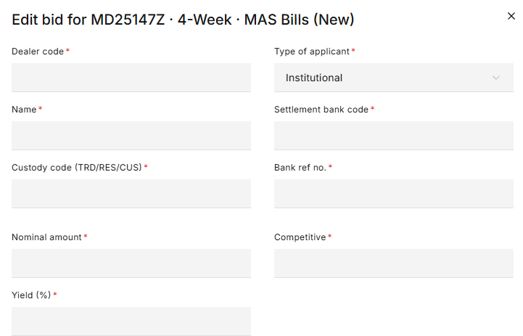
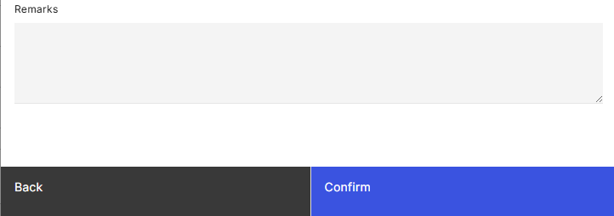
Figure 13: Update Bid Confirmation Prompt

Screen Elements
S/N | Name | Type  (Max Length) | Validation Rules | Remarks
1 | Issue code . Tenor . Security type New/reopen . SubType (if applicable) | Modal title |  | e.g. "Edit bid for MD25147Z · 4-week · MAS Bills (New)".
2 | Dealer code | Label
3 | Type of applicant | Label
4 | Name | Label
5 | Settlement bank code | Label
6 | Custody code | Label
7 | NRIC/Passport no. | Label
8 | Applicant name | Label
9 | Nationality | Label
10 | Application type | Label
11 | CDP account no. | Label
12 | CPF/SRS account no. | Label
13 | Bank ref. no. | Label
14 | Nominal amount ($) | Label
15 | Competitive | Label
16 | Yield (%) | Label
17 | Remarks (internal) | Label |  | Refer to MAS_OMEGA – Functional Specifications Document (Common Functions) for the screen elements used and its functionalities.
18 | Confirm | Primary button |  | Submits the updated bid for approval. Refer to 2.9.4 Post Conditions.
Table 20: Update Bid Confirmation Prompt Screen Elements

Delete Bid

Description
This use case enables Makers to delete bids for an issuance.

Preconditions
- User logs in to the Intranet Portal.
- User accesses the Bid Details Page.
- The result for the auction/allotment is not released or is unpublished.
- The bid is not pending approval for updates or requests for deletion.

Business Requirements
- Role-based Access Control:
  - Bid Collation Maker
- File uploads and batch files cannot be used to delete bids.
- Bids that are pending approval cannot be deleted without approving, rejecting, or withdrawing the original request.

Post Conditions
- An instance of the BPMN workflow is created.
- The deleted bid will appear in the Pending Approvals Accordion and awaiting approval.
- The event is added to the audit log and submission history.
- Emails and notifications are sent to the checkers to inform them of the deletion of the bid which was submitted for approval.
- User stays in the Bid Details Page.
- User views a temporary toast notification informing that the request to delete the bid was successful.

Bid Details Page
The Bid Details page contains additional element in the Data Table (for institutional bids) and the Data Table (for retail bids).

Wireframe
Refer to 2.7.6.1 Wireframe.

Data Tables (for both institutional bids and retail bids)
S/N | Name | Type  (Max Length) | Validation Rules | Remarks
1 | Delete | Icon |  | Opens the Delete Bid Modal.
Table 21: Data Table Screen Elements

Delete Bid Modal

Wireframe
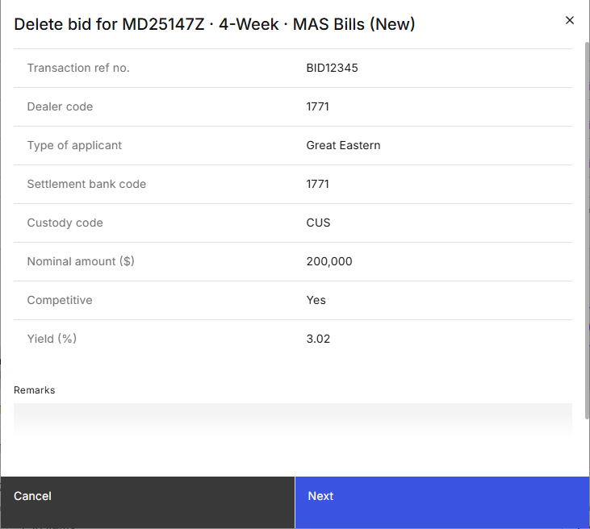
Figure 14: Delete Bid Modal

Screen Elements
S/N | Name | Type  (Max Length) | Validation Rules | Remarks
1 | Issue code . Tenor . Security type New/reopen . SubType (if applicable) | Modal title |  | e.g. "Delete bid for MD25147Z · 4-week · MAS Bills (New)".
2 | Dealer code | Label
3 | Type of applicant | Label
4 | Name | Label
5 | Settlement bank code | Label
6 | Custody code | Label
7 | NRIC/Passport no. | Label
8 | Applicant name | Label
9 | Nationality | Label
10 | Application type | Label
11 | CDP account no. | Label
12 | CPF/SRS account no. | Label
13 | Bank ref. no. | Label
14 | Nominal amount ($) | Label
15 | Competitive | Label
16 | Yield (%) | Label
17 | Remarks (internal) | Label |  | Refer to MAS_OMEGA – Functional Specifications Document (Common Functions) for the screen elements used and its functionalities.
18 | Next | Primary button |  | Displays the Delete Bid Confirmation Prompt.
Table 22: Delete Bid Modal Screen Elements

Delete Bid Confirmation Prompt

Wireframe
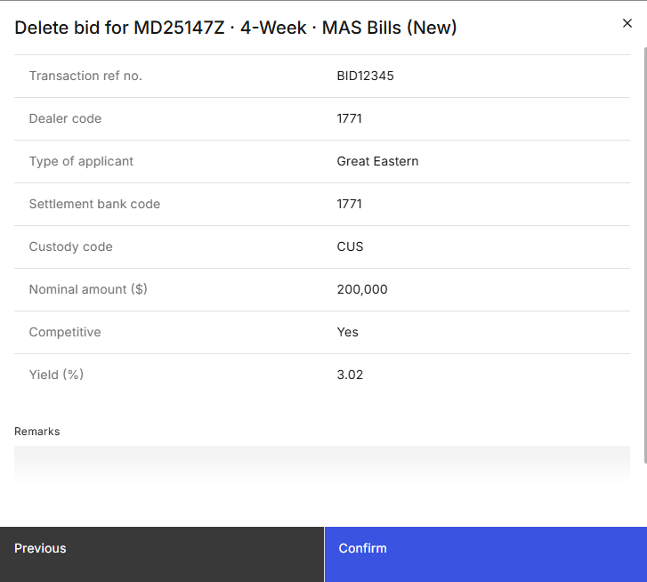
Figure 15: Delete Bid Confirmation Prompt

Screen Elements
S/N | Name | Type  (Max Length) | Validation Rules | Remarks
1 | Issue code . Tenor . Security type New/reopen . SubType (if applicable) | Modal title |  | e.g. "Delete bid for MD25147Z · 4-week · MAS Bills (New)".
2 | Dealer code | Label
3 | Type of applicant | Label
4 | Name | Label
5 | Settlement bank code | Label
6 | Custody code | Label
7 | NRIC/Passport no. | Label
8 | Applicant name | Label
9 | Nationality | Label
10 | Application type | Label
11 | CDP account no. | Label
12 | CPF/SRS account no. | Label
13 | Bank ref. no. | Label
14 | Nominal amount ($) | Label
15 | Competitive | Label
16 | Yield (%) | Label
17 | Remarks (internal) | Label |  | Refer to MAS_OMEGA – Functional Specifications Document (Common Functions) for the screen elements used and its functionalities.
18 | Confirm | Primary button |  | Submits the deletion for approval. Refer to 2.10.4 Post Conditions.
Table 23: Delete Bid Confirmation Prompt Screen Elements

Withdraw Bid Approval Request

Description
This use case enables Makers to withdraw submitted bid approval requests. This is typically used when approval for the bid is not required at the point in time i.e., there are further changes to be made to the bid, or the bid no longer needs to be created or deleted.

Preconditions
- User logs in to the Intranet Portal.
- User accesses the Bid Details Page.
- There are one or more items in the Pending Approvals Accordion.

Business Requirements
- Role-based Access Control:
  - Bid Collation Maker

Post Conditions
- The instance of the BPMN workflow that was created when the bid was submitted for approval is suspended.
- The event is added to the audit log and submission history.
- Emails are sent to the checkers to inform them of the bid(s) which was withdrawn.
- User remains in the Bid Details Page.
- User views a temporary toast notification informing that the request to withdraw the bid was successful.

Bid Details page
The Bid Details page contains additional elements in the Pending Approvals Accordion.

Wireframe
Refer to 2.7.6.1 Wireframe.

Pending Approvals Accordion
S/N | Name | Type  (Max Length) | Validation Rules | Remarks
1 | Withdraw | Button |  | Opens the Withdraw Bid Modal.
Table 24: Pending Approvals Accordion Screen Elements

Withdraw Bid Modal

Wireframe
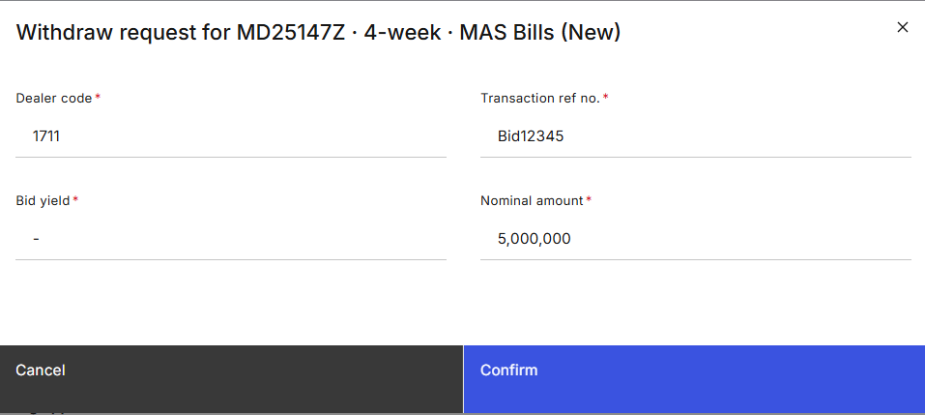
Figure 16: Withdraw Bid Modal

Screen Elements
S/N | Name | Type  (Max Length) | Validation Rules | Remarks
1 | Issue code . Tenor . Security type New/reopen . SubType (if applicable) | Modal title |  | e.g. "Withdraw request for MD25147Z · 4-week · MAS Bills (New)".
2 | Dealer code | Label
3 | Bank ref. no. | Label
4 | Nominal amount ($) | Label
5 | Yield (%) | Label
6 | Confirm | Primary button |  | Withdraws the approval request submitted for this bid. Refer to 2.11.4 Post Conditions.
Table 25: Review Bid Modal Screen Elements

Approve/Reject Bids

Description
This use case enables Checkers to approve or reject bids that are pending approval for creation, update, or deletion.

Preconditions
- User logs in to the Intranet Portal.
- User accesses the Bid Details Page.
- There are bids that are pending approval in the Bid Details Page.
- The allotment process for the issuance is not ongoing.

Business Requirements
- Role-based Access Control:
  - Bid Collation Checker
- Checkers are not allowed to approve or reject the bids which they have submitted for approval.
- Checkers are not allowed to reject bids without entering remarks.
- To approve or reject bids, checkers will need to perform key verification of the following fields: Dealer code, bank ref. no., yield and nominal amount.

Post Conditions
- The bid is either:
  - approved and will be created, updated, or deleted immediately, OR
  - rejected and not created or deleted, OR
  - rejected and reverted to its original bid detail without any changes (if the rejection was for an update).
- Emails are sent to inform users that the bid has been approved or rejected.
- User remains in the Bid Details Page.
- User views a temporary toast notification informing that the approval or rejection was successful.

Bid Details page
The Bid Details page contains additional elements in the Pending Approvals Accordion.

Wireframe
Refer to 2.7.6.1 Wireframe.

Pending Approvals Accordion
S/N | Name | Type  (Max Length) | Validation Rules | Remarks
1 | Review | Button |  | Opens the Review Bid Modal.
Table 26: Pending Approvals Accordion Screen Elements

Review Bid Modal

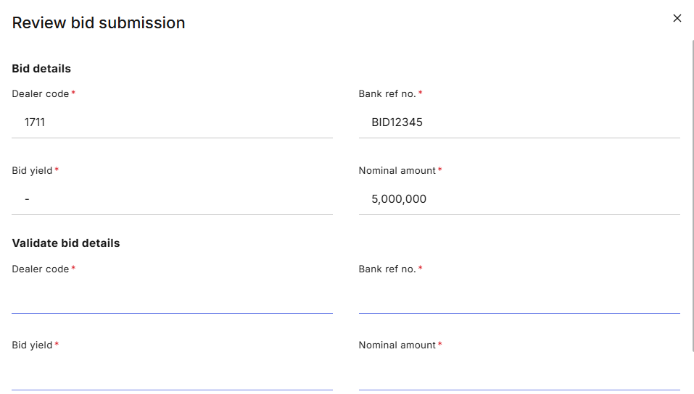
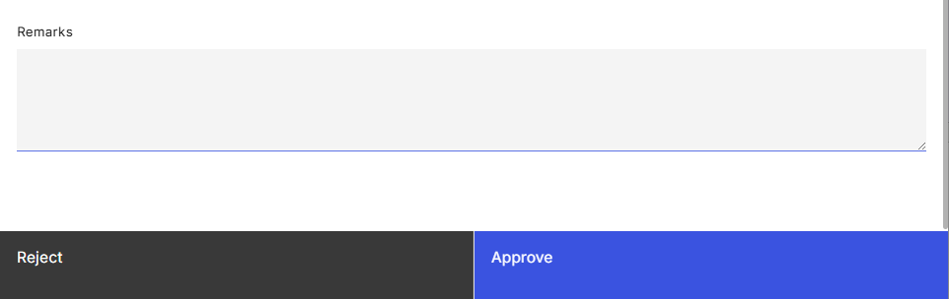
Wireframe
Figure 17: Review Bid Modal

Screen Elements
S/N | Name | Type  (Max Length) | Validation Rules | Remarks
1 | Issue code . Tenor . Security type New/reopen . SubType (if applicable) | Modal title |  | e.g. "Review bid for MD25147Z · 4-week · MAS Bills (New)".
2 | Dealer code | Label
3 | Bank ref. no. | Label
4 | Nominal amount ($) | Label
5 | Yield (%) | Label
6 | Dealer code | Text (4) | Hard Validations:  - Required field.  - Must be same value as the label above.
7 | Bank ref. no. | Text (8) | Hard Validations:  - Required field.  - Must be same value as the label above.
8 | Nominal amount ($) | Text (15) | Hard Validations:  - Required field.  - Must be same value as the label above.
9 | Yield (%) | Text (5v2) | Hard Validations:  - Required field.  - Must be same value as the label above.
10 | Remarks (internal) |  |  | Refer to MAS_OMEGA – Functional Specifications Document (Common Functions) for the screen elements used and its functionalities.
11 | Reject | Secondary button |  | Displays the Review Bid Confirmation Prompt.
12 | Approve | Primary button |  | Displays the Review Bid Confirmation Prompt.
Table 27: Review Bid Modal Screen Elements

Review Bid Confirmation Prompt

Wireframe

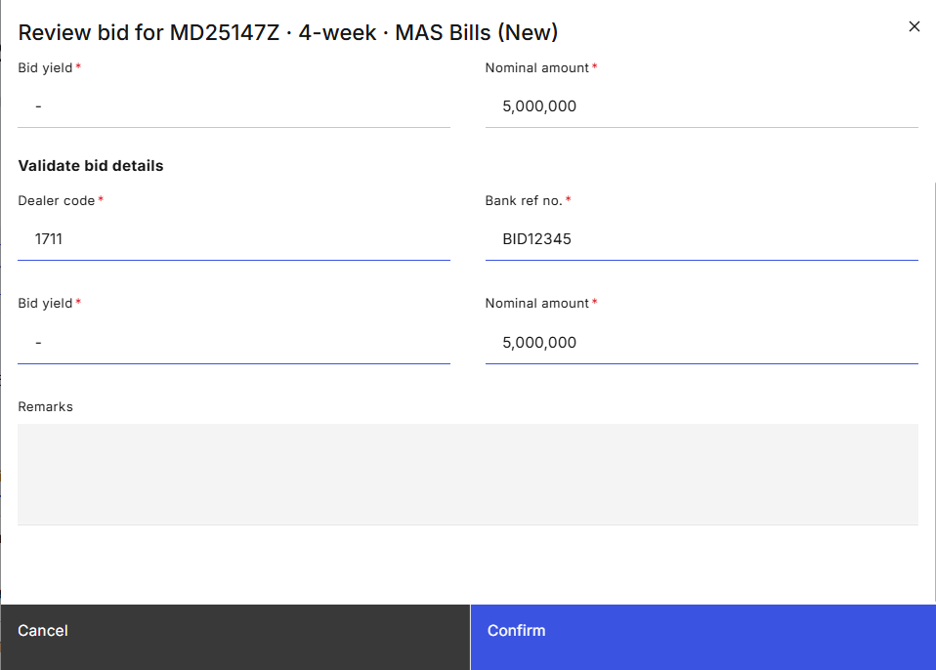
Figure 18: Review Bid Confirmation Prompt

Screen Elements
S/N | Name | Type  (Max Length) | Validation Rules | Remarks
1 | Issue code . Tenor . Security type New/reopen . SubType (if applicable) | Modal title |  | e.g. "Review bid for MD25147Z · 4-week · MAS Bills (New)".
2 | Dealer code | Label
3 | Bank ref. no. | Label
4 | Nominal amount ($) | Label
5 | Yield (%) | Label
6 | Internal remarks | Label |  | Refer to MAS_OMEGA – Functional Specifications Document (Common Functions) for the screen elements used and its functionalities.
7 | Confirm |  |  | Approves or rejects the approval request submitted for this bid. Refer to 2.12.4 Post Conditions.
Table 28: Review Bid Confirmation Prompt Screen Elements

Download Bid File Template

Description
This use case enables users to download bid file templates. This is used for Makers to retrieve the relevant bid file templates for forwarding to PDs to input.

Preconditions
- User logs in to the Intranet Portal.
- User accesses the Bid Details Page.

Business Requirements
- Role-based Access Control:
  - Bid Collation Maker
- There are two templates available: one for institutional bids and one for retail bids. Refer to for a list of templates available.

Post Conditions
- Download of the template is initiated.
- User remains in the Bid Details Page.

Bid Details page
The Bid Details Page contains additional elements in the Page Header.

Wireframe
Refer to 2.8.5 Bid Details Page.

Page Header
S/N | Name | Type  (Max Length) | Validation Rules | Remarks
1 | Download templates | Tertiary button with Dropdown |  | Open a menu list where templates used for file upload can be selected for download. Options available are:  - Institutional bid template  - Retail bid template  When the option is clicked, refer to 2.13.6 Template Files for the file to be downloaded.
Table 29: Page Header Screen Elements

Template Files

Export Bids

Description
This use case enables users to export bids.

Preconditions
- User logs in to the Intranet Portal.
- User accesses the Bid Details Page.

Business Requirements
- Role-based Access Control:
  - Bid Collation Viewer
  - Bid Collation Maker
  - Bid Collation Checker
- Exports include bids that are created via batch files and manual entry submitted by FIs and MAS.
- Exports only include bids that are successfully submitted, i.e. not pending approval or rejected.
- As the data fields are different for institutional and retail bids, they are exported as separate files.
- Each file contains bids for one issuance.

Post Conditions
- Download of the file is initiated.
- User remains in the Bid Details page.

Bid Details page
The Bid Details Page contains additional elements in the Data Table Action Header for both institutional bids and retail bids.

Wireframe
Refer to 2.8.5 Bid Details Page.

Data Table Action Header
S/N | Name | Type  (Max Length) | Validation Rules | Remarks
1 | Export | Tertiary button |  | Refer to 2.14.4 Post Conditions.
Table 30: Data Table Action Header Screen Elements

Sample Files
Refer to the following files for a sample of the export:

